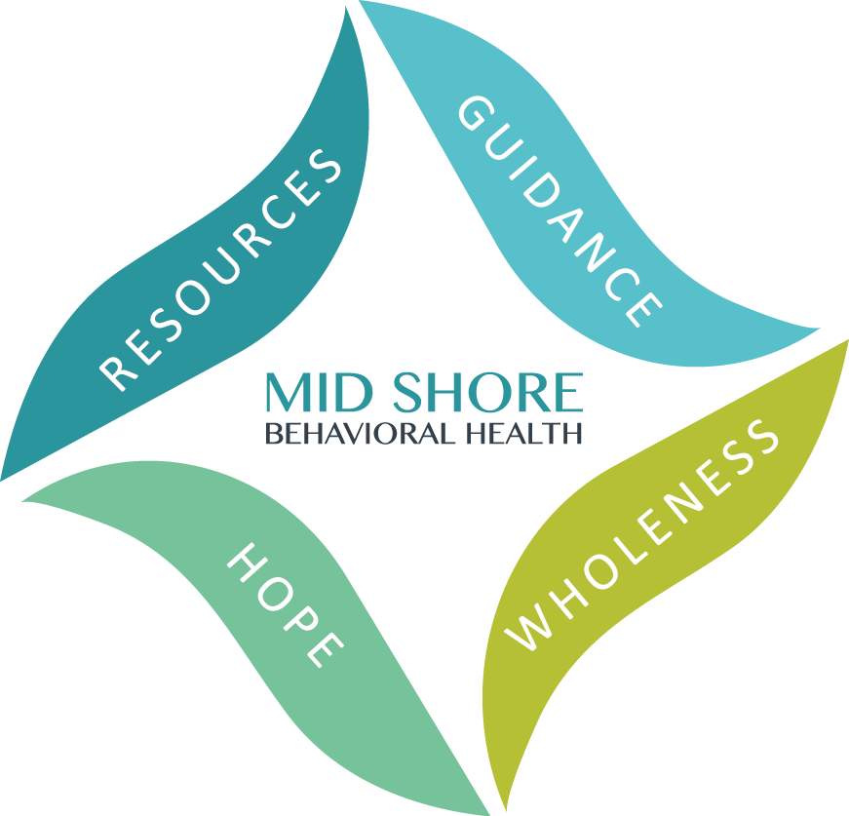
Mid Shore Behavioral Health, Inc.
2020 Caliber Awards
Achieving Excellence in Public Behavioral Health

Nomination Form

Nominated by: ______________________________________________________

Please list Provider and/or Program Name along with a brief statement of why you think this person/program should be recognized. Please submit by Friday, April 3, 2020.

Achieving Excellence through Effective Programming
This award recognizes programs which are effective in improving the provision of behavioral health services for residents in the mid-shore region. Nominees will have demonstrated effective collaboration with consumers, family members, providers, and community leaders, using creative and cost-effective methods.

Nominee: ____________________________________________________________________________________________________

Reason for nomination: ___________________________________________________________________________________________
___________________________________________________________________________________________
___________________________________________________________________________________________
___________________________________________________________________________________________
___________________________________________________________________________________________
___________________________________________________________________________________________
___________________________________________________________________________________________
___________________________________________________________________________________________
___________________________________________________________________________________________
___________________________________________________________________________________________
___________________________________________________________________________________________
___________________________________________________________________________________________

Achieving Excellence through the Empowerment of Consumers
This award recognizes initiatives that have fostered the empowerment of consumers in the public behavioral health system through the promotion of wellness and recovery. Initiatives nominated for this award have helped to form a more resilience-oriented system of care, providing consumers with support to improve their health and wellness, live a self-directed life, and achieve their fullest potential.

Nominee: ____________________________________________________________________________________________________

Reason for nomination:
___________________________________________________________________________________________
___________________________________________________________________________________________
___________________________________________________________________________________________
___________________________________________________________________________________________
___________________________________________________________________________________________
___________________________________________________________________________________________
___________________________________________________________________________________________
___________________________________________________________________________________________
___________________________________________________________________________________________
___________________________________________________________________________________________
___________________________________________________________________________________________
___________________________________________________________________________________________
___________________________________________________________________________________________
___________________________________________________________________________________________
___________________________________________________________________________________________
___________________________________________________________________________________________

Achieving Excellence through Interagency & Community Collaboration
This award recognizes a provider’s efforts and initiatives successfully collaborate with other agencies to provide easily accessible and needed services, support, and/or opportunities that improve the quality of life for consumers in the public behavioral health system.

Nominee: ____________________________________________________________________________________________________

Reason for nomination:
___________________________________________________________________________________________
___________________________________________________________________________________________
___________________________________________________________________________________________
___________________________________________________________________________________________
___________________________________________________________________________________________
___________________________________________________________________________________________
___________________________________________________________________________________________
___________________________________________________________________________________________
___________________________________________________________________________________________
___________________________________________________________________________________________
___________________________________________________________________________________________
___________________________________________________________________________________________
___________________________________________________________________________________________
___________________________________________________________________________________________
___________________________________________________________________________________________
___________________________________________________________________________________________
___________________________________________________________________________________________
___________________________________________________________________________________________
___________________________________________________________________________________________
___________________________________________________________________________________________
___________________________________________________________________________________________
___________________________________________________________________________________________
___________________________________________________________________________________________
___________________________________________________________________________________________

Lifetime Achievement Award
This award recognizes a professional life of hard work, dedication, and contributions by an individual who has shown through their commitment and dedicated focus on improving the public behavioral health system.

Nominee: ____________________________________________________________________________________________________

Reason for nomination:
___________________________________________________________________________________________
___________________________________________________________________________________________
___________________________________________________________________________________________
___________________________________________________________________________________________
___________________________________________________________________________________________
___________________________________________________________________________________________
___________________________________________________________________________________________
___________________________________________________________________________________________
___________________________________________________________________________________________
___________________________________________________________________________________________
___________________________________________________________________________________________
___________________________________________________________________________________________
___________________________________________________________________________________________
___________________________________________________________________________________________
___________________________________________________________________________________________
___________________________________________________________________________________________
___________________________________________________________________________________________
___________________________________________________________________________________________
___________________________________________________________________________________________
___________________________________________________________________________________________
___________________________________________________________________________________________
___________________________________________________________________________________________
___________________________________________________________________________________________
___________________________________________________________________________________________

_{Mary Beth Brennaman Award}
This award recognizes an outstanding individual who demonstrates an unconditional commitment to, and passion for, the mission and vision of his or her organization. This individual brings sincere compassion to the population served, and humor, generosity, spirit, and an overall outstanding attitude to the workplace. The individual eligible for the Mary Beth Brennaman Award can be any person in an agency who demonstrates an exceptionally positive attitude and support for their team, and consumers served.

Nominee: ____________________________________________________________________________________________________

Reason for nomination:
___________________________________________________________________________________________
___________________________________________________________________________________________
___________________________________________________________________________________________
___________________________________________________________________________________________
___________________________________________________________________________________________
___________________________________________________________________________________________
___________________________________________________________________________________________
___________________________________________________________________________________________
___________________________________________________________________________________________
___________________________________________________________________________________________
___________________________________________________________________________________________
___________________________________________________________________________________________
___________________________________________________________________________________________
___________________________________________________________________________________________
___________________________________________________________________________________________
___________________________________________________________________________________________
___________________________________________________________________________________________
___________________________________________________________________________________________ __________________________________________________________________________________________
___________________________________________________________________________________________

Special Recognition

If there is anyone else, you feel deserves recognition please list below and provide an explanation.

Consider the following categories:
- Prevention
- Leadership
- Defeating Stigma
- Suicide Prevention
- Substance Use
- Wellness and Recovery
- Unsung Hero
- Consumer Choice
- Behavioral Health Integration
- Peer Support
- Emergency/Crisis Services
- Education
- Trauma
- Advocacy

- Transitional Age Youth
- Deaf and Hard of Hearing
- Latino Pop
- Technology
- Volunteers
- Veterans
- Employment

Nominee: ____________________________________________________________________________________________________

Reason for nomination:
___________________________________________________________________________________________
___________________________________________________________________________________________
___________________________________________________________________________________________
___________________________________________________________________________________________
___________________________________________________________________________________________
___________________________________________________________________________________________
___________________________________________________________________________________________
___________________________________________________________________________________________
___________________________________________________________________________________________
___________________________________________________________________________________________
___________________________________________________________________________________________
___________________________________________________________________________________________
___________________________________________________________________________________________
___________________________________________________________________________________________
______________________________________________________________________________________________________________________________________________________________________________________

Nominee: ____________________________________________________________________________________________________

Reason for nomination:
___________________________________________________________________________________________
___________________________________________________________________________________________
___________________________________________________________________________________________
___________________________________________________________________________________________
___________________________________________________________________________________________
___________________________________________________________________________________________

Round Table on Homelessness Award

This award is to recognize an individual who has shown exemplary dedication to our group’s mission of ending homelessness in the mid-shore region. This individual is committed to developing relationships, collaborating with community partners, and connecting individuals and families to quality services, to foster resiliency and growth. This individual is a fierce and knowledgeable advocate for those experiencing homelessness in our communities and works diligently to improve service delivery across the continuum.

Nominee: ____________________________________________________________________________________________________

Reason for nomination:
___________________________________________________________________________________________
___________________________________________________________________________________________
___________________________________________________________________________________________
___________________________________________________________________________________________
___________________________________________________________________________________________
___________________________________________________________________________________________
___________________________________________________________________________________________
___________________________________________________________________________________________
___________________________________________________________________________________________
___________________________________________________________________________________________
___________________________________________________________________________________________
___________________________________________________________________________________________
___________________________________________________________________________________________
___________________________________________________________________________________________
___________________________________________________________________________________________
___________________________________________________________________________________________
___________________________________________________________________________________________
___________________________________________________________________________________________

Aging w/ Behavioral Health Disability Award

The ABHD Workgroup award recognizes an advocate for the most vulnerable in our community: those older adults who may be weakened by physical frailty and social isolation, and who struggle to find a place to gather strength and emotional support in their community. This aging advocate may help create this ‘place’ by devising a virtual cocoon of supportive services, or work with a community program or facility to enhance the opportunity to thrive. Through partnerships that span the Aging, Health and Social Services in our mid-shore region, this person recognizes the very real gaps in aging services and finds a way around them for the benefit of us all.
.

Nominee: ____________________________________________________________________________________________________

Reason for nomination:
___________________________________________________________________________________________
___________________________________________________________________________________________
___________________________________________________________________________________________
___________________________________________________________________________________________
___________________________________________________________________________________________
___________________________________________________________________________________________
___________________________________________________________________________________________
___________________________________________________________________________________________
___________________________________________________________________________________________
___________________________________________________________________________________________
___________________________________________________________________________________________
___________________________________________________________________________________________
___________________________________________________________________________________________
___________________________________________________________________________________________
___________________________________________________________________________________________
___________________________________________________________________________________________
___________________________________________________________________________________________
___________________________________________________________________________________________

Child & Adolescent Advocate Award

This award is to recognize an individual who has shown exemplary dedication to our group’s mission of all children and families will be safe and healthy in their communities, have access to quality behavioral health services and the opportunity to utilize supportive community resources. This individual is committed to developing relationships, collaborating with community partners, and connecting individuals and families to quality services, to foster resiliency and growth. This individual is a fierce and knowledgeable advocate for children, youth and families and works diligently to improve behavioral health service delivery across the continuum.

Nominee: ____________________________________________________________________________________________________

Reason for nomination:
___________________________________________________________________________________________
___________________________________________________________________________________________
___________________________________________________________________________________________
___________________________________________________________________________________________
___________________________________________________________________________________________
___________________________________________________________________________________________
___________________________________________________________________________________________
___________________________________________________________________________________________
___________________________________________________________________________________________
___________________________________________________________________________________________
___________________________________________________________________________________________
___________________________________________________________________________________________
___________________________________________________________________________________________
___________________________________________________________________________________________
___________________________________________________________________________________________
___________________________________________________________________________________________
___________________________________________________________________________________________
___________________________________________________________________________________________

Forensic Mental Health Award

The Forensic Mental Health Award honors a member of the workforce community or of the Forensic Workgroup. This nominee will be someone who serves tirelessly in the community advocating for clients that currently have judiciary requirements and behavioral health concerns. The recipient must be striving hard to help reduce stigma and trauma to this unique population of people.

Nominee: ____________________________________________________________________________________________________

Reason for nomination:
___________________________________________________________________________________________
___________________________________________________________________________________________
___________________________________________________________________________________________
___________________________________________________________________________________________
___________________________________________________________________________________________
___________________________________________________________________________________________
___________________________________________________________________________________________
___________________________________________________________________________________________
___________________________________________________________________________________________
___________________________________________________________________________________________
___________________________________________________________________________________________
___________________________________________________________________________________________
___________________________________________________________________________________________
___________________________________________________________________________________________
___________________________________________________________________________________________
___________________________________________________________________________________________
___________________________________________________________________________________________
___________________________________________________________________________________________

Ballot Submission

Completed forms can be submitted via:
- Fax to 410-770-4809;
- Email to surquhart@midshorebehavioralhealth.org; or
- Postal mail to:
  - ATTN: Sherize Urquhart, Marketing and Events Specialist
Mid Shore Behavioral Health, Inc.
28578 Mary’s Court, Suite 1
Easton, MD 21601

Rather submit electronically.
Ballots can also be submitted online via this link: https://www.surveymonkey.com/r/27MFFSD

